Application Assessment Report
Current state, health, technical debt, security and modernization analysis
Application | Live Test 09/29 B (APP-014)
Client | Example State Agency
Engagement | Application Portfolio Assessment
Version | v1.0 Final
Date | September 30, 2026
Classification | Confidential

Contents

Document control
1. Application summary
1.1 Executive snapshot
1.2 Key findings
1.3 Immediate actions
2. Business context and process mapping
2.1 Business purpose and ownership
2.2 User community
2.3 Business process map
2.4 Business calendar and timing
2.5 Business pain points and improvement opportunities
3. Technical profile
3.1 Application classification
3.2 Technology stack
3.3 Licensing and contracts
3.4 Configuration and customization
4. Architecture and integrations
4.1 Architecture diagram
4.2 Integration and data exchange inventory
4.3 Dependency analysis
4.4 Architecture observations
5. Data profile and reporting
5.1 Data inventory
5.2 Data quality and integrity
5.3 Reports and outputs
5.4 Analytics tooling
6. Application health and supportability
6.1 Health scorecard
6.2 End-of-life and supportability
7. Technical debt
7.1 Technical debt summary
7.2 Code quality indicators
7.3 Technical debt register
7.4 Architecture, infrastructure and process debt
7.5 Remediation priorities
8. Security and vulnerabilities
8.1 Security control assessment
8.2 Vulnerability assessment summary
8.3 Vulnerability register
8.4 Unsupported and vulnerable components
8.5 Regulatory and policy alignment
9. Risk and impact matrix
9.1 Risk register
9.2 Business impact of failure
9.3 Heat map placement
10. Operational support and IT dependency
10.1 Support model
10.2 Support demand (trailing 24 months)
10.3 Dependency reduction opportunities
10.4 Knowledge concentration
11. User experience
11.1 Usability assessment
11.2 User experience improvement opportunities
12. Modernization options and recommendation
12.1 Disposition options considered
12.2 Options evaluation
12.3 Recommendation
12.4 Sequencing and timing
13. Evidence, open items and sign-off
13.1 Stakeholder interviews
13.2 Documents and evidence reviewed
13.3 Assumptions and constraints
13.4 Open items
13.5 Review and acceptance
13.6 Appendices

Rating scales and definitions
Recommendations in this report describe options and priorities for the client to act on; they are not a design or implementation commitment.

Scores in this report are measured on a 0 to 100 scale (100 = best) from itemised deductions and converted to the condition scale below: 90 or more is 1 – Excellent, 75 to 89 is 2 – Good, 55 to 74 is 3 – Fair, 35 to 54 is 4 – Poor, and below 35 is 5 – Critical. Every rating states the deductions behind it.
Standard rating scales
Score | Likelihood of failure or issue | Business impact | Condition (health dimensions)
1 | Rare: not expected within 3 years | Minimal: workaround exists, no financial or compliance effect | Excellent: current, supported, well documented
2 | Unlikely: possible within 3 years | Minor: internal inconvenience, short delay | Good: minor gaps, supported
3 | Possible: plausible within 12 to 24 months | Moderate: delayed transactions or reports, manual rework | Fair: aging, partially supported, known gaps
4 | Likely: expected within 12 months | Major: missed regulatory deadline, customers or constituents affected | Poor: near end of support, fragile, key-person dependent
5 | Almost certain: occurring now or recurring | Severe: halted or incorrect core business operations, audit or legal exposure | Critical: unsupported, failing or unmaintainable

Risk score equals likelihood multiplied by impact (1 to 25). Scores of 15 and above are rated High, 8 to 14 Medium, and 7 and below Low.
Criticality tiers
Tier | Definition
Tier 1, Mission critical | Directly supports a core business function, financial transaction or regulatory obligation; outage tolerable for hours
Tier 2, Business essential | Supports a Tier 1 process or a regulated data collection; outage tolerable for days
Tier 3, Supporting | Internal analysis, convenience or reference use; outage tolerable for weeks

Document control
Field | Entry
Client | Example State Agency
Engagement | Application Portfolio Assessment
Application name | Live Test 09/29 B
Application ID | APP-014
Report version | v1.0 Final
Assessment period | 2026-09-29 to 2026-09-30
Prepared by | Ledelsea Assessment Team
Technical reviewer | Unknown
Business owner reviewer | Unknown
IT reviewer | Unknown
Classification | Confidential
Related applications (by ID) | None identified

Revision history
Version | Date | Author | Summary of changes
1.0 | 2026-09-30 | Ledelsea Assessment Team | Assessment report issued

1. Application summary
This section gives client leadership a one-page view of the application, its condition and the recommended direction before the detailed analysis that follows.
1.1 Executive snapshot
Attribute | Entry
Purpose in one sentence | Calculates and posts monthly state aid payments to school districts and lets staff look up payment status.
Business area or program supported | School finance
Business value or volume supported | Unknown
Criticality tier | Tier 1
Overall health rating (Section 6) | 2 – Good (1 is best, 5 is worst). This is the weighted average of the health scorecard in Section 6.1, where 5 of the 7 areas could be rated from the evidence.
Technical debt level (Section 7) | Low. 1 – Excellent. Maintainability scored 93 out of 100 (weakest file: 2_AIDPOST.rpgle, 79). Points were taken off because an outdated library or language feature is still in use (7 places, −49 points).
Open critical or high vulnerabilities (Section 8) | 4 (1 critical, 3 high); register in 8.3
Highest risk score (Section 9) | 20, High (R-014-01, 3_district_aid_lookup.html)
End-of-life exposure | jQuery 1.4.2 (unsupported)
Recommended disposition (Section 12) | Re-platform: Upgrade the out-of-date parts to supported versions, changing code only where needed.
Recommended timing | Short term, 0 to 12 months

1.2 Key findings
In short: Live Test 09/29 B is in good overall condition (2 on a scale where 1 is best and 5 is worst), but it has serious security problems and relies on technology the vendor no longer supports. The recommended direction is to re-platform: upgrade the out-of-date parts to supported versions, changing code only where needed (Section 12).
Security (Section 8). The review found 1 critical, 2 high and 7 medium issues. The most serious: a password or key is written directly into the code (hard-coded credential) (critical); data is sent without encryption (plain HTTP instead of HTTPS/TLS) (high); and sensitive data such as a password is sent in the web address (GET request) (high). Because the application handles personal data, a breach would expose personal records, so these issues are rated one level higher than they otherwise would be. Security is rated 5 – Critical (it scored 25 out of 100).
Supportability (Section 6.2). jQuery 1.4.2 is past the vendor's end of support. Unsupported software no longer receives security fixes, so its known weaknesses stay open until it is upgraded or replaced.
Risk (Section 9). The highest risk is R-014-01, 3_district_aid_lookup.html: 20 of 25, which is High. Likelihood 5 of 5, because its weakest area (security) scored 0 out of 100. Impact 4 of 5: it handles personal data (a default until the business owner rates it). Risk score 5 × 4 = 20 of 25.
Effort (Section 12.4). The recommended work is estimated at 4.0–12.5 person-weeks, about 1–3 months for one developer. The first items are quick security fixes that can be made before any wider modernization decision (Section 1.3).
1.3 Immediate actions
These problems should be fixed now, before any decision on modernization, because they expose data or users today:
# | Condition | Recommended interim action | Owner | Urgency
1 | Encrypt connections (3_district_aid_lookup.html). Why it matters: it can be read or changed on the network. | Enable TLS for service endpoints and database connections (Encrypt=True, https). | IT | Within 90 days
2 | Remove hard-coded credentials (3_district_aid_lookup.html). Why it matters: anyone who can read the code can use it, and it can't be changed without a code release. | Move secrets to a vault or protected configuration and rotate every exposed password. | IT | Within 30 days
3 | Harden UI security (3_district_aid_lookup.html). Why it matters: web addresses are stored in browser history and server logs. | POST sensitive forms, add anti-forgery tokens, mask passwords and personal identifiers, remove trusted values from hidden fields. | IT | Within 90 days

2. Business context and process mapping
This section establishes why the application exists, who depends on it, and how it fits into the business calendar, so that technical findings can be weighed against real business consequences.
2.1 Business purpose and ownership
Attribute | Entry
Business capability supported | Calculates and posts monthly state aid payments to school districts and lets staff look up payment status.
Regulatory, contractual or policy basis | Unknown
Business owner | Unknown
Subject matter experts | Unknown
Year introduced | Unknown
Known drivers of change | Unknown

2.2 User community
User group | Internal or external | Approximate number of users | Access method | Frequency and peak periods
Business users of the application screens | Unknown | Unknown | 4 screen(s): 3_district_aid_lookup, AIDDSP, AIDSCR, DISTRICT AID INQUIRY (AIDI) — Minnesota | Unknown

2.3 Business process map
The screen flow below is drawn from the screens and navigation in the source. Business actors, manual steps and handoffs outside the application are to be mapped with stakeholders (open item).
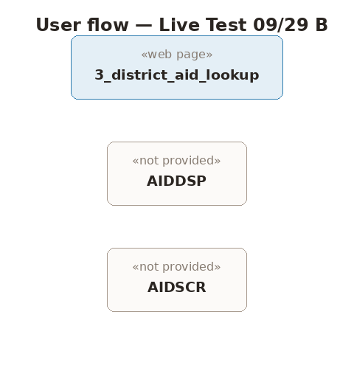
Figure 2. Current-state screen flow for Live Test 09/29 B, drawn from the screens and navigation in the source.
Step | Actor | Activity | Manual or automated | Inputs | Outputs | Pain point observed
No process steps could be derived from the source; to be mapped with stakeholders.

2.4 Business calendar and timing
Cycle or event | Timing | Dependency on this application | Consequence if unavailable
No scheduled cycles were identified in the source; business calendar to be confirmed with the business owner.

2.5 Business pain points and improvement opportunities
Stakeholder interviews were not part of this review, so pain points are not recorded in stakeholders' words (open item). Issues observable in the application itself:
Image without text alternative: 3_district_aid_lookup.html:29
Form field without a label: 3_district_aid_lookup.html:36
Form field without a label: 3_district_aid_lookup.html:42
Form field without a label: 3_district_aid_lookup.html:53
Form field without a label: 3_district_aid_lookup.html:54
Form field without a label: 3_district_aid_lookup.html:55
3. Technical profile
This section inventories every technical component of the application with its version and vendor support status, which forms the evidence base for the end-of-life and supportability ratings in Section 6.
3.1 Application classification
Attribute | Entry
Application type | Batch process, Online screens
Build origin | Custom built (application source code is maintained by the client)
Legacy lineage | 3 of 5 files are mainframe or midrange languages (Assembler, COBOL, RPG)
Deployment model | Unknown
Environments | Unknown
Source code location and control | Unknown
Size indicators | 454 lines in 5 files; 2 program(s), 2 screen(s), 3 table(s), 8 data store(s)

3.2 Technology stack
Layer | Technology and version | Vendor | Mainstream support end | Extended support end | Status
Presentation / UI | jQuery 1.4.2 | OpenJS Foundation | Unknown | Unknown | Unsupported
Application framework | None identified in the source
Programming languages | None identified in the source
Third-party libraries and components | None identified in the source
Database | IBM IMS (DB/DC) (version not confirmed) | IBM | Unknown | Unknown | Supported
Reporting | None identified in the source
Batch and scheduling | None identified in the source
Web and application server | Unknown
Operating system | IBM i (version not confirmed) | IBM | Unknown | Unknown | Version not confirmed
Identity and authentication | Unknown
Infrastructure | Unknown

3.3 Licensing and contracts
Product | License model | Quantity | Annual cost | Renewal date | Contract owner
Unknown

3.4 Configuration and customization
1 hard-coded value(s) were found in the source, including: Hard-coded credential: 3_district_aid_lookup.html:8.
Where routine policy or rate changes require a code change, the item appears in the technical debt register (7.3).
4. Architecture and integrations
This section provides the visual architecture map for the application, together with a complete inventory of the integrations and data exchanges that connect it to the rest of the portfolio.
4.1 Architecture diagram
The architecture below is drawn from the confirmed components in Section 3, in the standard layer order so it can be read alongside other application reports.
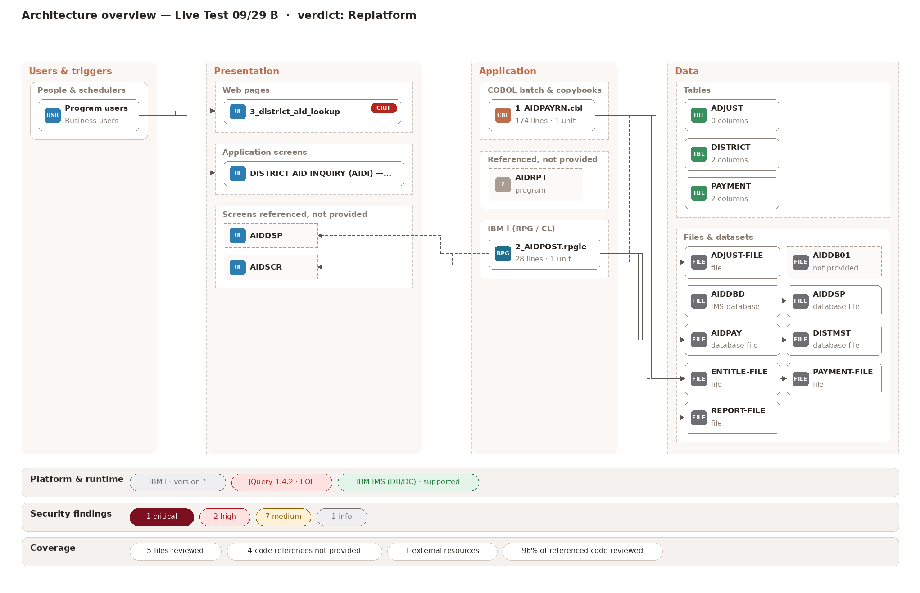
Figure 1. Logical architecture of Live Test 09/29 B: layers, components and the systems and data it touches.
Architecture at a glance
- Presentation layer: 3_district_aid_lookup.html, web page in HTML using jQuery 1.4.2; 4_aidinq_3270_SCREEN.html, 3270 terminal screen.
- Application layer: 2_AIDPOST.rpgle, interactive program (drives screens) in RPG using IBM i; 1_AIDPAYRN.cbl, batch program in COBOL.
- Data layer: AIDDBD-live.dbd, database definition in IMS DBD using IBM IMS (DB/DC).
- Data it holds: ADJUST-FILE, AIDDB01 (not provided), AIDDSP, AIDPAY, DISTMST, ENTITLE-FILE, PAYMENT-FILE, REPORT-FILE.
- Platforms: IBM i (AS/400), IBM mainframe (z/OS), Web browser.
Component inventory
Component | Layer | Role | Technology | Reads / uses | Writes
3_district_aid_lookup.html | Presentation | Web page | HTML, jQuery 1.4.2 | – | –
2_AIDPOST.rpgle | Application | Interactive program (drives screens) | RPG, IBM i | DISTMST, AIDDSP | AIDPAY
1_AIDPAYRN.cbl | Application | Batch program | COBOL | ENTITLE-FILE, ADJUST-FILE | PAYMENT-FILE, REPORT-FILE
4_aidinq_3270_SCREEN.html | Presentation | 3270 terminal screen | Unknown | – | –
AIDDBD-live.dbd | Data | Database definition | IMS DBD, IBM IMS (DB/DC) | AIDDB01 (not provided) | –

View | What it must show | Status
A. Logical architecture | Layers, modules and business functions, as in the reference layout | Complete (Figure 1)
B. Deployment (physical) architecture | Servers, environments, network zones, hosting location, disaster recovery arrangement | Pending: hosting and network detail not available
C. Integration context | This application at the center with every upstream and downstream system, labeled with interface IDs from 4.2 | Complete (Figure 3)
D. Data flow | Movement of key data entities from source to report, including manual handoffs and spreadsheet steps | Complete (Figure 4)
E. Portfolio position | Where the application sits in the overall application portfolio map | Pending: requires the portfolio inventory

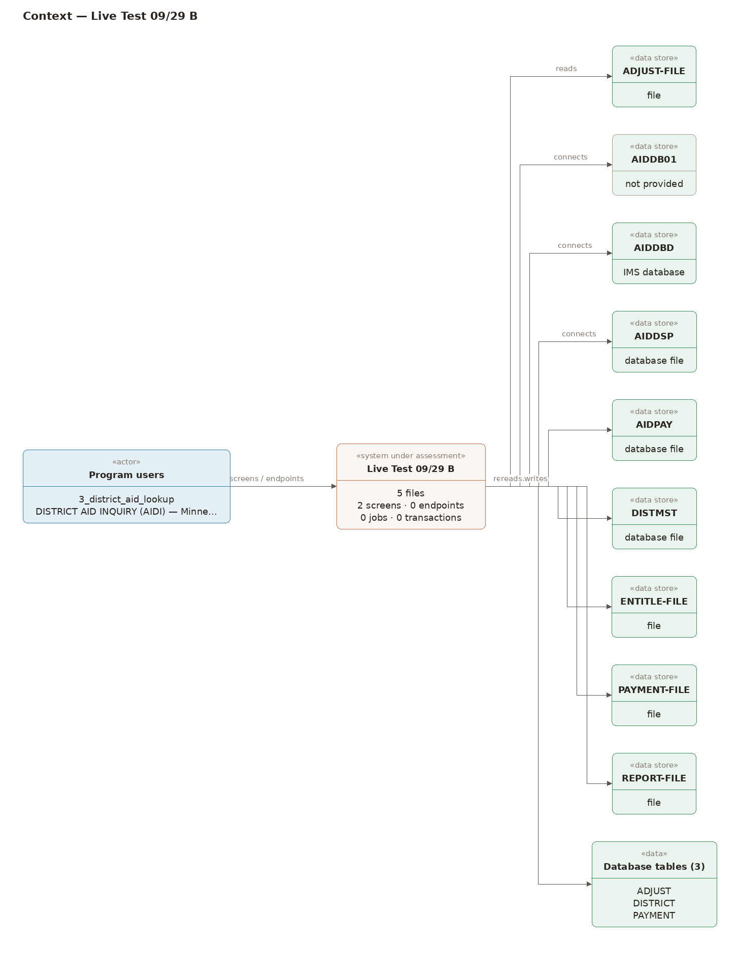
Figure 3. Integration context: the application with every upstream and downstream system and data store. Validation with the IT owner: pending.
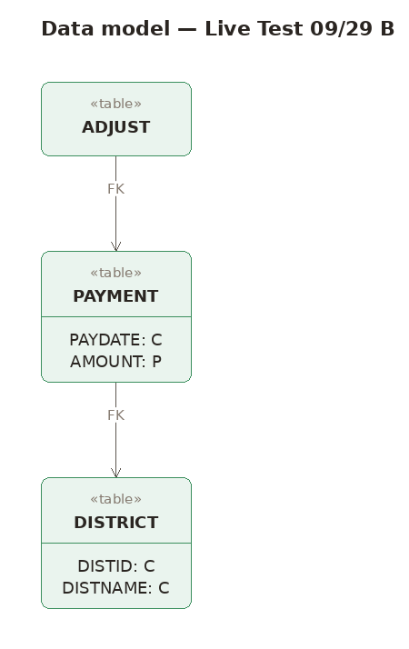
Figure 4. Data model: tables, columns and keys used by the application. Validation with the IT owner: pending.
4.2 Integration and data exchange inventory
Interface ID | Direction | Connected system (APP ID if in scope) | Data exchanged | Method | Format | Frequency and trigger | Owner | Failure handling | Documented
INT-014-01 | Inbound | ADJUST-FILE | Unknown | File or dataset | Fixed width | Unknown | Unknown | Unknown | No
INT-014-02 | Unknown | AIDDBD | Unknown | File or dataset | Fixed width | Unknown | Unknown | Unknown | No
INT-014-03 | Unknown | AIDDSP | Unknown | File or dataset | Fixed width | Unknown | Unknown | Unknown | No
INT-014-04 | Bidirectional | AIDPAY | Unknown | File or dataset | Fixed width | Unknown | Unknown | Unknown | No
INT-014-05 | Inbound | DISTMST | Unknown | File or dataset | Fixed width | Unknown | Unknown | Unknown | No
INT-014-06 | Inbound | ENTITLE-FILE | Unknown | File or dataset | Fixed width | Unknown | Unknown | Unknown | No
INT-014-07 | Outbound | PAYMENT-FILE | Unknown | File or dataset | Fixed width | Unknown | Unknown | Unknown | No
INT-014-08 | Outbound | REPORT-FILE | Unknown | File or dataset | Fixed width | Unknown | Unknown | Unknown | No
How data moves between the components
- 2_AIDPOST.rpgle (interactive program (drives screens)): reads DISTMST, AIDDSP; writes AIDPAY; shows screens AIDDSP (not provided), AIDSCR (not provided); calls CALCAID (not provided), AIDRPT (not provided).
- 1_AIDPAYRN.cbl (batch program): reads ENTITLE-FILE, ADJUST-FILE; writes PAYMENT-FILE, REPORT-FILE.
- AIDDBD-live.dbd (database definition): defines AIDDB01 (not provided).

4.3 Dependency analysis
- Systems this application depends on: AIDDB01
- Systems that depend on this application: Unknown
- Shared components: ADJUST, DISTRICT, PAYMENT
- Hidden or informal dependencies: programs referenced but not provided: AIDRPT, AIDDSP, AIDSCR

4.4 Architecture observations
The application spans several platforms. What we see: Its 5 components run on 3 platforms: IBM i (AS/400) (2_AIDPOST.rpgle); IBM mainframe (z/OS) (1_AIDPAYRN.cbl, 4_aidinq_3270_SCREEN.html, AIDDBD-live.dbd); Web browser (3_district_aid_lookup.html). Why it matters: Each platform needs its own skills, hosting, release process and support contract, and modernizing one leaves the others as they are. A target architecture should reduce the number of platforms.
Components exchange data through files and shared data stores, not APIs. What we see: 8 data store(s) connect the components, including 4 sequential file(s) (ENTITLE-FILE, ADJUST-FILE, PAYMENT-FILE, REPORT-FILE). No service or API layer was found. Why it matters: Every file layout and shared table is an unwritten contract between programs. A replacement must reproduce each one, and there is no single interface a new front end or partner system could use.
Business rules sit inside the programs. What we see: Calculation and validation routines were found in the code: CALCAID in 2_AIDPOST.rpgle; 2100-APPLY-ADJUSTMENTS, 2200-COMPUTE-HOLDBACK in 1_AIDPAYRN.cbl. Why it matters: These rules are the application's real value and are undocumented outside the code. Any option other than retain must extract them first, and ideally move them into a tested, configurable rules layer.
The user interface is split across technologies. What we see: Users work through 2 screen(s): 3_district_aid_lookup.html (Web page, jQuery 1.4.2); 4_aidinq_3270_SCREEN.html (3270 terminal screen). Why it matters: Terminal screens and old web pages can't meet current accessibility standards and need special skills to change. A single web front end over an API would serve both user groups.
Parts of the application were not provided. What we see: 3 referenced component(s) are missing: AIDRPT (program), AIDDSP (screen), AIDSCR (screen). Why it matters: The architecture and the risk ratings cover only what was provided; these parts could change the picture, especially if they hold business rules or integrations.
Security is built into each program rather than provided centrally. What we see: 3 finding(s) show credentials held in code and connections without encryption, rather than a shared identity service and encrypted transport. Why it matters: Each component must be fixed separately. The target should use the organisation's identity service, a secrets store and TLS everywhere, so security is handled once.
Code-level coupling (calls between files) is rated 1 – Excellent: Dependencies scored 100 out of 100. No problems were found. This score counts program-to-program calls only; the data-level coupling described above is not included in it.
5. Data profile and reporting
This section documents what data the application owns, how trustworthy it is, and which reports depend on it, including external reports that any modernization option must account for.
5.1 Data inventory
Data entity | System of record (Y/N) | Approximate volume | Retention requirement | Data classification | Contains personal or regulated data
ADJUST | Unknown | Unknown | Unknown | Restricted | Personal data
DISTRICT | Unknown | Unknown | Unknown | Restricted | Personal data
PAYMENT | Unknown | Unknown | Unknown | Restricted | Personal data
ADJUST-FILE (file) | Unknown | Unknown | Unknown | Internal | Unknown
AIDDB01 (file) | Unknown | Unknown | Unknown | Internal | Unknown
AIDDBD (file) | Unknown | Unknown | Unknown | Internal | Unknown
AIDDSP (file) | Unknown | Unknown | Unknown | Internal | Unknown
AIDPAY (file) | Unknown | Unknown | Unknown | Internal | Unknown
DISTMST (file) | Unknown | Unknown | Unknown | Internal | Unknown
ENTITLE-FILE (file) | Unknown | Unknown | Unknown | Internal | Unknown
PAYMENT-FILE (file) | Unknown | Unknown | Unknown | Internal | Unknown
REPORT-FILE (file) | Unknown | Unknown | Unknown | Internal | Unknown

5.2 Data quality and integrity
Dimension | Rating (1 to 5) | Evidence and observations
Accuracy | Not rated | Requires access to production data; not part of this review.
Completeness | Not rated | Requires access to production data; not part of this review.
Timeliness | Not rated | Requires access to production data; not part of this review.
Consistency across systems | Not rated | Requires access to production data; not part of this review.
Validation controls | Not rated | Requires access to production data; not part of this review.
Data lineage and documentation | Not rated | Requires access to production data; not part of this review.

5.3 Reports and outputs
Report ID | Report name | Audience | Tool | Frequency | Regulatory or contractual requirement | Manual effort to produce | Recommended future state
None identified in the material reviewed.

5.4 Analytics tooling
No analytical or statistical tooling was identified in the source reviewed.
6. Application health and supportability
This section produces the overall health rating for the application. Each dimension is scored on the 1 to 5 condition scale, and the overall rating is the weighted average shown in the final row.
6.1 Health scorecard
Dimension | Weight | Score (1 to 5) | Weighted score | Evidence
Technology currency and vendor support | 20% | 2 | 0.40 | Supportability scored 87 out of 100 (weakest file: 3_district_aid_lookup.html, 65). Points were taken off because jQuery 1 is past the vendor's end of support (end of life) (2 places, −36.5 points); and few people still have the skills to maintain this technology (3 places, −30 points).
Code quality and maintainability | 15% | 1 | 0.15 | Maintainability scored 93 out of 100 (weakest file: 2_AIDPOST.rpgle, 79). Points were taken off because an outdated library or language feature is still in use (7 places, −49 points). Complexity scored 100 out of 100. No problems were found.
Stability and reliability | 15% | 1 | 0.15 | Code health scored 99 out of 100 (weakest file: 2_AIDPOST.rpgle, 88). Points were taken off because it calls programs that were not provided for this review (−12 points); and no compiler for this language was available to confirm the file compiles (−5 points).
Performance and scalability | 10% | Not rated | Excluded | Not rated: no evidence for this dimension in the material reviewed (open item).
Security posture | 15% | 5 | 0.75 | Security scored 25 out of 100 (weakest file: 3_district_aid_lookup.html, 0). Points were taken off because a published security weakness (CVE) exists in jQuery 1.4.2 (5 places, −35 points); a password or key is written directly into the code (hard-coded credential) (−25 points); and 6 smaller issue(s) (−76 points).
Documentation and knowledge | 10% | Not rated | Excluded | Not rated: no evidence for this dimension in the material reviewed (open item).
Business fit and adaptability | 15% | 1 | 0.15 | Dependencies scored 100 out of 100. No problems were found.
Overall health rating | 100% | 2 | 2.0 | 2.0 – Good. The weighted average of the 5 areas that could be rated; the weights of the 2 unrated areas are left out, so the total is taken over 80%.

6.2 End-of-life and supportability
Component | Current version | End of mainstream support | End of extended support | Months remaining from assessment date | Upgrade path available | Notes
jQuery | 1.4.2 | Not published | Not published |  | Yes | script / library reference
IBM IMS (DB/DC) | Not confirmed | Not published | Not published |  | Not applicable | IMS 15 is supported; hierarchical DL/I data and MFS screens are scarce skills. Confirm the

7. Technical debt
This section identifies the shortcuts, outdated constructs and structural weaknesses that make the application harder and more expensive to change, and estimates the effort needed to remediate them.
7.1 Technical debt summary
Attribute | Entry
Overall technical debt level | Low. 1 – Excellent. Maintainability scored 93 out of 100 (weakest file: 2_AIDPOST.rpgle, 79). Points were taken off because an outdated library or language feature is still in use (7 places, −49 points).
Dominant debt categories | Code
Estimated total remediation effort | Included in the roadmap total of 4.0–12.5 person-weeks
Effect on delivery | An outdated library or language feature is still in use (3_district_aid_lookup.html): it makes changes riskier and blocks upgrades.
Trend | Not measurable from a single point-in-time review

7.2 Code quality indicators
Indicators below are measured from the source code provided for this review; indicators that need a running build or test suite are marked not measured.
Indicator | Measured value | Acceptable threshold | Tool or method | Observation
Lines of code (by language) | COBOL: 174, UI screen: 124, HTML: 115, RPG: 28, Assembler: 13 | Not applicable | Source code review
Average and maximum cyclomatic complexity | average 4.6, maximum 13 (1_AIDPAYRN.cbl) | Under 15 per routine | Decision-point count per file | Within threshold
Code duplication | Not measured | Under 5% |  | Not assessed in this review
Maintainability rating or code smells | 1 (Excellent) | 2 (Good) or better | Technical debt score | 93/100; deductions in 7.1
Automated test coverage | 0% (no automated tests found in the source) | 60% or higher | Source code review | No test suite provided
Outdated third-party dependencies | 1 | 0 | Version and support-date review
Dead or unused code | Not measured |  |  | Not assessed in this review
Share of machine-translated or generated legacy code | 0% | Not applicable | Source code review
Hard-coded values (rates, paths, credentials, dates) | 1 | 0 | Source code review | Hard-coded credential: 3_district_aid_lookup.html:8

7.3 Technical debt register
Debt ID | Description | Category | Root cause | Impact on operations and change | Remediation approach | Estimated effort | Priority
TD-014-01 | An outdated library or language feature is still in use: legacy construct: jQuery 1.4.2 (known XSS issues before 3.5) (3_district_aid_lookup.html) | Code | Library or construct not upgraded | It makes changes riskier and blocks upgrades (−7 maintainability points) | Upgrade or replace | M | Medium
TD-014-02 | An outdated library or language feature is still in use: legacy construct: doctype DTD HTML 4.01 Transitional (3_district_aid_lookup.html) | Code | Library or construct not upgraded | It makes changes riskier and blocks upgrades (−7 maintainability points) | Upgrade or replace | M | Medium
TD-014-03 | An outdated library or language feature is still in use: legacy construct: QCMDEXC command strings (2_AIDPOST.rpgle) | Code | Library or construct not upgraded | It makes changes riskier and blocks upgrades (−7 maintainability points) | Upgrade or replace | M | Medium
TD-014-04 | An outdated library or language feature is still in use: legacy construct: RPG cycle / indicators (*INxx) (2_AIDPOST.rpgle) | Code | Library or construct not upgraded | It makes changes riskier and blocks upgrades (−7 maintainability points) | Upgrade or replace | M | Medium
TD-014-05 | An outdated library or language feature is still in use: legacy construct: fixed-form RPG (column-sensitive) (2_AIDPOST.rpgle) | Code | Library or construct not upgraded | It makes changes riskier and blocks upgrades (−7 maintainability points) | Upgrade or replace | M | Medium
TD-014-06 | An outdated library or language feature is still in use: legacy construct: 3270 terminal (4_aidinq_3270_SCREEN.html) | Code | Library or construct not upgraded | It makes changes riskier and blocks upgrades (−7 maintainability points) | Upgrade or replace | M | Medium
TD-014-07 | An outdated library or language feature is still in use: legacy construct: IMS hierarchical database (AIDDBD-live.dbd) | Code | Library or construct not upgraded | It makes changes riskier and blocks upgrades (−7 maintainability points) | Upgrade or replace | M | Medium

7.4 Architecture, infrastructure and process debt
Skills: few people still have COBOL/CICS; RPG / IBM i; and mainframe assembler skills, so support depends on a small, shrinking pool of in-house staff or vendors.
Release automation, environment parity and batch dependency documentation could not be assessed and are open items.
7.5 Remediation priorities
Quick wins to reduce risk now, independent of modernization: Encrypt connections; Remove hard-coded credentials; Harden UI security.
Because the recommended disposition (Re-platform) keeps the current code, every item in 7.3 can be fixed directly.
8. Security and vulnerabilities
This section assesses the application's security controls and known vulnerabilities so that modernization options address them rather than carrying them forward. Exploitable detail such as hostnames, IP addresses and proof-of-concept steps belongs in the restricted appendix, not in the body of this report.
8.1 Security control assessment
Control area | Current state | Gap identified | Rating (1 to 5)
Authentication (SSO, MFA, application-managed passwords) | 1 issue(s): The password box shows the password as it is typed. | Anyone nearby can read it. | 3 – Fair: the most serious issue here is medium
Authorization and role-based access | Unknown | Not assessed | Not rated: this can't be seen in the code
Privileged and service account management | Unknown | Not assessed | Not rated: this can't be seen in the code
Secrets management (credentials in code, config files, scripts) | 1 issue(s): A password or key is written directly into the code (hard-coded credential). | Anyone who can read the code can use it, and it can't be changed without a code release. | 5 – Critical: the most serious issue here is critical
Encryption in transit | 1 issue(s): Data is sent without encryption (plain HTTP instead of HTTPS/TLS). | It can be read or changed on the network. | 4 – Poor: the most serious issue here is high
Encryption at rest | No issues found in the source reviewed | None identified | 2 – Good: nothing found in the code; not yet confirmed on the running system
Input validation and output encoding | 2 issue(s): User input is written into the web page without being made safe (cross-site scripting, XSS). | An attacker could run their own script in a user's browser. | 3 – Fair: the most serious issue here is medium
Audit logging and monitoring | Unknown | Not assessed | Not rated: this can't be seen in the code
Patch management | 5 issue(s): A published security weakness (CVE) exists in jQuery 1.4.2. | Attackers know about it and fixes exist. | 3 – Fair: the most serious issue here is medium
Secure development practices | Unknown | Not assessed | Not rated: this can't be seen in the code
Backup, recovery and resilience | Unknown | Not assessed | Not rated: this can't be seen in the code
Third-party and vendor risk | 5 issue(s): A published security weakness (CVE) exists in jQuery 1.4.2. | Attackers know about it and fixes exist. | 3 – Fair: the most serious issue here is medium

8.2 Vulnerability assessment summary
Assessment type | Tool | Date performed | Scope | Critical | High | Medium | Low
Infrastructure and OS review | Not performed |  | Not in scope
Web application review (DAST) | Not performed |  | Not in scope
Static code analysis (SAST) | Source code review | 2026-09-30 | 5 files | 1 | 3 | 3 | 0
Software composition analysis (third-party libraries) | Version and CVE review | 2026-09-30 | 3 components | 0 | 0 | 5 | 0
Database configuration review | Not performed |  | Not in scope
Penetration test (if available) | Not performed |  | Not in scope

8.3 Vulnerability register
Vuln ID | Affected component | CVE or CWE reference | CVSS score | Severity | Exposure | Exploit known (Y/N) | Recommended remediation | Owner | Target date | Status | Restricted detail ref
VUL-014-01 | 3_district_aid_lookup.html:8 | CWE-798 | Not scored | Critical | Unknown | N | Change the password and move it to a secrets store | IT | 2026-10-30 | Open | Appendix D
VUL-014-02 | 3_district_aid_lookup.html:6 | CWE-319 | Not scored | High | Unknown | N | Switch the connection to HTTPS (TLS 1.2 or later) | IT | 2026-12-29 | Open
VUL-014-03 | 3_district_aid_lookup.html:6 | CWE-319 | Not scored | High | Internet facing | N | Load everything over HTTPS | IT | 2026-12-29 | Open
VUL-014-04 | 3_district_aid_lookup.html:32 | CWE-598 | Not scored | High | Internet facing | N | Send it in the request body (POST) | IT | 2026-12-29 | Open
VUL-014-05 | 3_district_aid_lookup.html | CVE-2012-6708, CWE-1395 | Not scored | Medium | Unknown | Y | Upgrade to a fixed version | IT | 2027-03-29 | Open
VUL-014-06 | 3_district_aid_lookup.html | CVE-2015-9251, CWE-1395 | Not scored | Medium | Unknown | Y | Upgrade to a fixed version | IT | 2027-03-29 | Open
VUL-014-07 | 3_district_aid_lookup.html | CVE-2019-11358, CWE-1395 | Not scored | Medium | Unknown | Y | Upgrade to a fixed version | IT | 2027-03-29 | Open
VUL-014-08 | 3_district_aid_lookup.html | CVE-2020-11022, CWE-1395 | Not scored | Medium | Unknown | Y | Upgrade to a fixed version | IT | 2027-03-29 | Open
VUL-014-09 | 3_district_aid_lookup.html | CVE-2020-11023, CWE-1395 | Not scored | Medium | Unknown | Y | Upgrade to a fixed version | IT | 2027-03-29 | Open
VUL-014-10 | 3_district_aid_lookup.html:61 | CWE-549 | Not scored | Medium | Internet facing | N | Use a masked password field | IT | 2027-03-29 | Open
VUL-014-11 | 3_district_aid_lookup.html:12 | CWE-79 | Not scored | Medium | Unknown | N | Encode everything written to the page; avoid innerHTML and document.write | IT | 2027-03-29 | Open
VUL-014-12 | 3_district_aid_lookup.html:17 | CWE-79 | Not scored | Medium | Unknown | N | Encode everything written to the page; avoid innerHTML and document.write | IT | 2027-03-29 | Open
What these findings mean, in plain terms:
- VUL-014-01: a password or key is written directly into the code (hard-coded credential). Why it matters: anyone who can read the code can use it, and it can't be changed without a code release. Fix: move it to a secure secrets store and change the password.
- VUL-014-02: data is sent without encryption (plain HTTP instead of HTTPS/TLS). Why it matters: it can be read or changed on the network. Fix: switch the connection to HTTPS (TLS 1.2 or later).
- VUL-014-03: part of the page is loaded over unencrypted HTTP (mixed content). Why it matters: that part can be tampered with on the network. Fix: load everything over HTTPS.
- VUL-014-04: sensitive data such as a password is sent in the web address (GET request). Why it matters: web addresses are stored in browser history and server logs. Fix: send it in the request body (POST).
- VUL-014-05 to VUL-014-09: a published security weakness (CVE) exists in jQuery 1.4.2. Why it matters: attackers know about it and fixes exist. Fix: upgrade to a fixed version.
- VUL-014-10: the password box shows the password as it is typed. Why it matters: anyone nearby can read it. Fix: use a masked password field.
- VUL-014-11 and VUL-014-12: user input is written into the web page without being made safe (cross-site scripting, XSS). Why it matters: an attacker could run their own script in a user's browser. Fix: encode everything written to the page; avoid innerHTML and document.write.

8.4 Unsupported and vulnerable components
jQuery 1.4.2: unsupported. Compensating controls: unknown (open item).
8.5 Regulatory and policy alignment
Requirement | Applies (Y/N) | Compliance status | Notes
Client information security policy and standards | Y | Not assessed | Unknown
Security framework in use (e.g., NIST CSF, NIST SP 800-53, ISO 27001, CIS Controls) | Y | Partial | NIST SP 800-53 controls referenced by the findings in 8.3
Data privacy obligations (e.g., HIPAA, FERPA, GDPR, CCPA, state data practices law) | Y | Partial | FERPA: personal data is handled; see 8.3
Payment card data (PCI DSS) | N | Not assessed
Records retention schedule | Unknown | Not assessed
Open internal or external audit findings | Unknown | Not assessed

9. Risk and impact matrix
This section consolidates the risks identified in Sections 3 through 8 into a single scored register, which is aggregated across all applications to produce the portfolio risk and impact matrix.
9.1 Risk register
Risk ID | Risk description | Category | Likelihood (1 to 5) | Impact (1 to 5) | Score | Rating | Existing mitigation | Recommended mitigation
R-014-01 | 3_district_aid_lookup.html: Runs on an end-of-life runtime with a supported successor | Technology | 5 | 4 | 20 | High | Unknown | Replatform: Upgrade the out-of-date parts to supported versions, changing code only where needed.
R-014-02 | 2_AIDPOST.rpgle: no serious weakness found; every area scored fair or better | Technology | 1 | 4 | 4 | Low | Unknown | Retain: Keep the application as it is, with routine maintenance only.
R-014-03 | 1_AIDPAYRN.cbl: no serious weakness found; every area scored fair or better | Technology | 1 | 4 | 4 | Low | Unknown | Retain: Keep the application as it is, with routine maintenance only.
R-014-04 | 4_aidinq_3270_SCREEN.html: no serious weakness found; every area scored fair or better | Security | 1 | 3 | 3 | Low | Unknown | Retain: Keep the application as it is, with routine maintenance only.
R-014-05 | AIDDBD-live.dbd: no serious weakness found; every area scored fair or better | Technology | 1 | 2 | 2 | Low | Unknown | Retain: Keep the application as it is, with routine maintenance only.
Why each risk is rated as it is:
- R-014-01 (3_district_aid_lookup.html): Likelihood 5 of 5, because its weakest area (security) scored 0 out of 100. Impact 4 of 5: it handles personal data (a default until the business owner rates it). Risk score 5 × 4 = 20 of 25.
- R-014-02 (2_AIDPOST.rpgle): Likelihood 1 of 5, because its weakest area (supportability) scored 88 out of 100. Impact 4 of 5: it writes program data (a default until the business owner rates it). Risk score 1 × 4 = 4 of 25.
- R-014-03 (1_AIDPAYRN.cbl): Likelihood 1 of 5, because its weakest area (supportability) scored 90 out of 100. Impact 4 of 5: it writes program data (a default until the business owner rates it). Risk score 1 × 4 = 4 of 25.
- R-014-04 (4_aidinq_3270_SCREEN.html): Likelihood 1 of 5, because its weakest area (security) scored 100 out of 100. Impact 3 of 5: it user- or job-facing entry point (a default until the business owner rates it). Risk score 1 × 3 = 3 of 25.
- R-014-05 (AIDDBD-live.dbd): Likelihood 1 of 5, because its weakest area (supportability) scored 90 out of 100. Impact 2 of 5: it supporting component (a default until the business owner rates it). Risk score 1 × 2 = 2 of 25.

9.2 Business impact of failure
Scenario | Affected users and business functions | Maximum tolerable outage | Current workaround | Estimated consequence
Complete outage during a peak business cycle | Unknown | Unknown | Unknown | Delayed service; see the business calendar (2.4)
Processing or calculation error undetected | 5 files of business logic | Not applicable | None identified in the source | Incorrect outputs and recovery effort
Security breach or data exposure | Personal data | Not applicable | Unknown | Notification obligations and legal exposure
Loss of key technical staff | Maintenance of the COBOL/CICS; RPG / IBM i; and mainframe assembler code | Not applicable | Unknown | Inability to maintain or change the application

9.3 Heat map placement
Each risk from 9.1 is placed on the 5 by 5 grid below (likelihood across, impact up). The application's heat-map position is set by its highest risk, R-014-01 at 20.
Impact 5 | 5 | 10 | 15 | 20 | 25
Impact 4 | 4 / R-014-02, R-014-03 | 8 | 12 | 16 | 20 / R-014-01
Impact 3 | 3 / R-014-04 | 6 | 9 | 12 | 15
Impact 2 | 2 / R-014-05 | 4 | 6 | 8 | 10
Impact 1 | 1 | 2 | 3 | 4 | 5
 | Likelihood 1 | Likelihood 2 | Likelihood 3 | Likelihood 4 | Likelihood 5
Shading: red = High (15 to 25), amber = Medium (8 to 14), green = Low (1 to 7). The number in each cell is the risk score.
10. Operational support and IT dependency
This section quantifies the effort required to keep the application running and identifies which activities could shift from IT to business users through configuration, self-service or better tooling.
10.1 Support model
Attribute | Entry
Support team and named contacts | Unknown
Number of staff able to support the application | Unknown
Vendor support arrangement | Unknown
Service level or availability target | Unknown
Change and release process | Unknown
Monitoring and alerting | Unknown

10.2 Support demand (trailing 24 months)
Measure | Value | Source
Incidents logged | Unknown | Service management records not provided
Service requests | Unknown | Service management records not provided
Change requests implemented | Unknown | Service management records not provided
Estimated IT support hours per year | Unknown | Service management records not provided
Estimated business staff hours per year on workarounds | Unknown | Service management records not provided

10.3 Dependency reduction opportunities
Recurring IT activity | Hours per year | Root cause | Opportunity to reduce dependency | Enabler required
Change to hard-coded value: Hard-coded credential: 3_district_aid_lookup.html:8 | Unknown | Value held in source code | Move to a business-maintained table | Configuration screen and change controls

10.4 Knowledge concentration
Few people still have COBOL/CICS; RPG / IBM i; and mainframe assembler skills, so the application depends on a small, shrinking pool of staff or vendors. The names of the people who can maintain it today are an open item.
11. User experience
This section evaluates how well the application serves its internal and external users, based on interviews, observation and support history.
11.1 Usability assessment
Dimension | Rating (1 to 5) | Observations
Ease of navigation and task completion | 2 | Good: warning message uses a cryptic code (AID0142W) and points to another screen (AIDA) by code: 4_aidinq_3270_SCREEN.html (−2 points); screen codes (AIDI, AIDA) are cryptic and have no descriptive labels: 4_aidinq_3270_SCREEN.html (−2 points); and 5 smaller issue(s) (−10 points).
Clarity of error messages and validation feedback | Not rated | No evidence in the material reviewed (error handling)
Efficiency for high-volume or repetitive tasks | Not rated | Requires observation of users at work
Consistency with other client applications | Not rated | Requires the portfolio inventory
Mobile and browser compatibility | Not rated | No evidence in the material reviewed (browser support)
Availability of help, guidance and training | Not rated | Not visible in the source
User satisfaction reported in interviews | Not rated | Stakeholder interviews not held

11.2 User experience improvement opportunities
User experience and accessibility are rated 2 (Good): 2 – Good. Usability and accessibility scored 81 out of 100 (weakest file: 3_district_aid_lookup.html, 40). Points were taken off because a form field has no label that a screen reader can announce (6 places, −36 points); text is too faint against its background (2 places, −12 points); an image has no text description (−6 points); and 12 smaller issue(s) (−26 points).
Accessibility (measured against WCAG 2.1 AA, the usual legal standard): a form field has no label that a screen reader can announce (6 places, −36 points); text is too faint against its background (2 places, −12 points); an image has no text description (−6 points); a data table has no header cells (2 places, −4 points); and 4 smaller issue(s) (−8 points).
12. Modernization options and recommendation
This section compares the credible modernization approaches for the application and records the recommended disposition, prioritized by the risk rating in Section 9. Options are described at a planning level and remain vendor and product neutral.
12.1 Disposition options considered
Option | Description | Applicable to this application
Retain | Continue as is with routine maintenance | No: unsupported components must be addressed
Re-host | Move to current infrastructure or cloud without code change | No: moving infrastructure alone does not close the findings in Section 8
Re-platform | Move to a supported platform with limited code change | Yes: recommended
Refactor | Restructure code or architecture while retaining function | Partly: for the debt items in 7.3
Replace | Adopt a commercial, SaaS or shared solution | Not assessed: requires a market review
Consolidate | Merge with other applications into a shared platform | Not assessed: requires the portfolio inventory
Retire | Decommission and move residual function elsewhere | No: the function is still in use

12.2 Options evaluation
Each shortlisted option is scored from 1 (poor) to 5 (strong). Weighted totals: Re-platform 3.40, Refactor 3.55, Retain 1.95. Rationale:
- Re-platform: closes end-of-life and known-vulnerability exposure with targeted code change; keeps proven business logic, so value and debt retired are moderate.
- Refactor: fixes security findings and restructures the worst code on the current platform; retires the most debt short of a rebuild, with moderate disruption.
- Retain: no disruption, but every finding and end-of-life exposure remains open.
Criterion | Weight | Option A: Re-platform | Option B: Refactor | Option C: Retain
Risk reduction (including security and end-of-life exposure) | 25% | 4 | 4 | 1
Business value and user benefit | 20% | 3 | 3 | 2
Technical debt retired | 15% | 3 | 4 | 1
Implementation complexity and disruption | 15% | 3 | 3 | 5
Reduction in IT dependency | 10% | 3 | 3 | 1
Alignment with client enterprise architecture standards | 10% | 4 | 4 | 2
Alignment with industry or peer practice | 5% | 4 | 4 | 2
Weighted total | 100% | 3.40 | 3.55 | 1.95

12.3 Recommendation
Item | Entry
Recommended disposition | Re-platform
Rationale | 23% of the code runs on end-of-life or dead-end technology: jQuery 1: end of life Rebuild or move those components (see component dispositions); keep the rest
Consolidation grouping | None identified
Prerequisites | Provide 4 missing component(s); Confirm business criticality
Key risks of the recommended option | Regression in business calculations during change; mitigated by parallel runs against current outputs
Interim risk mitigation until modernized | Encrypt connections; Remove hard-coded credentials; Harden UI security
Target architecture (outline)
A planning-level view of where each layer should end up under the recommended option; it is product-neutral and needs validating with the enterprise architecture team:
- Presentation: Replace the terminal screens and legacy web pages with one accessible web front end (WCAG 2.1 AA) that calls the application through an API; it can be built screen by screen while the old ones run.
- Application: Keep the proven business logic, but move it to a supported runtime and expose it as services (for example REST APIs); batch programs can stay batch, run by a modern scheduler.
- Data: Keep each data store with a single owning service; document file layouts as data contracts, and plan the move from files and hierarchical databases to a relational or managed store where the vendor path requires it.
- Integration: Replace file drops and direct program calls with the API layer or managed file transfer, with monitoring and retry, so each interface is visible and supported.
- Cross-cutting: use the organisation's identity service for sign-in, a secrets store for credentials, TLS on every connection, and central logging and monitoring.

12.4 Sequencing and timing
Item | Entry
Recommended horizon | Short term, 0 to 12 months
Proposed start window | Unknown
Estimated duration | 1–3 months for one developer (4.0–12.5 person-weeks)
Predecessor initiatives | Provide 4 missing component(s); Confirm business criticality
Successor initiatives | None identified
Business blackout periods | Unknown

13. Evidence, open items and sign-off
This section records where each finding came from, what remains unresolved, and the formal acceptance of the report by the client.
13.1 Stakeholder interviews
No stakeholder interviews were held as part of this review; findings rest on the source code, screens and configuration listed in 13.2.
Interview ref | Date | Participants and roles | Organization or unit | Topics covered | Other APP IDs covered
None |  |  |  | Stakeholder interviews were not part of this review

13.2 Documents and evidence reviewed
Evidence ref | Title or description | Type | Date or version | Location
EV-014-01 | 1_AIDPAYRN.cbl | Source code | v1, 2026-09-29 | Program source set: 1_AIDPAYRN.cbl
EV-014-02 | 2_AIDPOST.rpgle | Source code | v1, 2026-09-29 | Program source set: 2_AIDPOST.rpgle
EV-014-03 | 3_district_aid_lookup.html | Source code | v1, 2026-09-29 | Program source set: 3_district_aid_lookup.html
EV-014-04 | 4_aidinq_3270_SCREEN.html | Application screen | v1, 2026-09-29 | Program source set: 4_aidinq_3270_SCREEN.html
EV-014-05 | AIDDBD-live.dbd | Source code | v4, 2026-09-29 | Program source set: AIDDBD-live.dbd

13.3 Assumptions and constraints
- Findings reflect the source files listed in 13.2; components not provided are listed in 4.3 and are not scored.
- Business impact defaults to a moderate rating where the business owner has not rated criticality (Section 9).
- Support dates are from published vendor lifecycle information current at the report date.
- Assessment confidence is medium: 96% of referenced code reviewed (4 missing); 1 technology version(s) unconfirmed; business criticality not entered — impact uses defaults.
- No access to production systems, data, service management records or stakeholders was part of this review.

13.4 Open items
Item | Description | Owner | Due date | Status
OI-014-01 | Technical reviewer (Section Document control) | Assessment lead | 2026-10-30 | Open
OI-014-02 | Business owner reviewer (Section Document control) | Business owner | 2026-10-30 | Open
OI-014-03 | IT reviewer (Section Document control) | IT | 2026-10-30 | Open
OI-014-04 | Business value or volume supported (Section 1.1) | Business owner | 2026-10-30 | Open
OI-014-05 | Regulatory, contractual or policy basis (Section 2.1) | Business owner | 2026-10-30 | Open
OI-014-06 | Subject matter experts (Section 2.1) | Business owner | 2026-10-30 | Open
OI-014-07 | Year introduced and major rewrites (Section 2.1) | Business owner | 2026-10-30 | Open
OI-014-08 | Known drivers of change (Section 2.1) | Business owner | 2026-10-30 | Open
OI-014-09 | Number of users by group (Section 2.2) | Business owner | 2026-10-30 | Open
OI-014-10 | Swimlane process map with business actors and manual steps (Section 2.3) | Business owner | 2026-10-30 | Open
OI-014-11 | Business pain points in stakeholders' words (interviews) (Section 2.5) | Business owner | 2026-10-30 | Open
OI-014-12 | Deployment model and hosting (Section 3.1) | IT | 2026-10-30 | Open
OI-014-13 | Environments (production, test, development, disaster recovery) (Section 3.1) | IT | 2026-10-30 | Open
OI-014-14 | Source code repository and version control (Section 3.1) | IT | 2026-10-30 | Open
OI-014-15 | Web and application server and version (Section 3.2) | IT | 2026-10-30 | Open
OI-014-16 | Identity and authentication and version (Section 3.2) | IT | 2026-10-30 | Open
OI-014-17 | Infrastructure and version (Section 3.2) | IT | 2026-10-30 | Open
OI-014-18 | Licensing and contracts for commercial products (Section 3.3) | IT | 2026-10-30 | Open
OI-014-19 | Deployment (physical) architecture: servers, environments, network zones (Section 4.1) | IT | 2026-10-30 | Open
OI-014-20 | Frequency, owner and failure handling of each interface in 4.2 (Section 4.2) | IT | 2026-10-30 | Open
OI-014-21 | Downstream systems (Section 4.3) | IT | 2026-10-30 | Open
OI-014-22 | Data volumes, retention requirements and system-of-record status (5.1) (Section 5.1) | Business owner | 2026-10-30 | Open
OI-014-23 | Data quality ratings (requires production data) (Section 5.2) | Business owner | 2026-10-30 | Open
OI-014-24 | Release, deployment and environment practices (Section 7.4) | IT | 2026-10-30 | Open
OI-014-25 | Security control: authorization (Section 8.1) | Information security | 2026-10-30 | Open
OI-014-26 | Security control: privileged (Section 8.1) | Information security | 2026-10-30 | Open
OI-014-27 | Security control: audit logging (Section 8.1) | Information security | 2026-10-30 | Open
OI-014-28 | Security control: secure development (Section 8.1) | Information security | 2026-10-30 | Open
OI-014-29 | Security control: backup (Section 8.1) | Information security | 2026-10-30 | Open
OI-014-30 | Compensating controls for unsupported components (Section 8.4) | Information security | 2026-10-30 | Open
OI-014-31 | Client security policy and standards (Section 8.5) | Information security | 2026-10-30 | Open
OI-014-32 | Maximum tolerable outage and current workarounds (9.2) (Section 9.2) | Business owner | 2026-10-30 | Open
OI-014-33 | Support team and named contacts (Section 10.1) | IT | 2026-10-30 | Open
OI-014-34 | Number of staff able to support (Section 10.1) | IT | 2026-10-30 | Open
OI-014-35 | Vendor support arrangement (Section 10.1) | IT | 2026-10-30 | Open
OI-014-36 | Service level or availability target (Section 10.1) | IT | 2026-10-30 | Open
OI-014-37 | Change and release process (Section 10.1) | IT | 2026-10-30 | Open
OI-014-38 | Monitoring and alerting (Section 10.1) | IT | 2026-10-30 | Open
OI-014-39 | Support demand for the trailing 24 months (10.2) (Section 10.2) | IT | 2026-10-30 | Open
OI-014-40 | Individuals holding key knowledge of the application (Section 10.4) | IT | 2026-10-30 | Open
OI-014-41 | Proposed start window (fiscal year and quarter) (Section 12.4) | Business owner | 2026-10-30 | Open
OI-014-42 | Business blackout periods (Section 12.4) | Business owner | 2026-10-30 | Open
OI-014-43 | Stakeholder interviews (Section 13.1) | Assessment lead | 2026-10-30 | Open
OI-014-44 | Provide the source of program AIDRPT (referenced but not provided) (Section 4.3) | IT | 2026-10-30 | Open
OI-014-45 | Provide the source of screen AIDDSP (referenced but not provided) (Section 4.3) | IT | 2026-10-30 | Open
OI-014-46 | Provide the source of screen AIDSCR (referenced but not provided) (Section 4.3) | IT | 2026-10-30 | Open

13.5 Review and acceptance
Role | Name | Organization | Decision | Date
Assessment lead | Ledelsea Assessment Team | Ledelsea | Submitted | 2026-09-30
Business owner |  | Example State Agency
IT application or architecture lead |  | Example State Agency
Information security reviewer |  | Example State Agency
Client project manager |  | Example State Agency

13.6 Appendices
- Appendix A: Architecture diagrams in editable Visio (.vsdx) and draw.io formats, supplied with this report
- Appendix B: Technology and component inventory (Sections 3.2 and 6.2)
- Appendix C: Technical debt detail (Section 7.3)
- Appendix D: Restricted security findings, supplied separately to named security staff
- Appendix E: Screen flow (Figure 2)
- Appendix F: Report catalog (Section 5.3)
- Appendix G: Glossary of technical terms (below)
Appendix G. Glossary
Term | Meaning
3270 | The IBM mainframe terminal ('green screen') format.
CICS | IBM's mainframe system for online (screen-based) transactions.
COBOL | A business programming language from 1959, still widely used on mainframes.
CVE | Common Vulnerabilities and Exposures: the public list of known security weaknesses in software.
CVSS | Common Vulnerability Scoring System: a 0–10 severity score for a known weakness.
CWE | Common Weakness Enumeration: the standard catalogue of kinds of software weakness.
Cyclomatic complexity | The number of independent paths through a routine; higher means harder to test.
DBD | Database description: the definition of an IMS database's structure.
End of life | The vendor has stopped releasing fixes, including security fixes.
Hard-coded credential | A password or key written into the code itself.
HTTPS | The encrypted version of HTTP, the protocol web pages use.
IBM i | IBM's midrange operating system (formerly AS/400).
IMS | IBM's hierarchical mainframe database and transaction manager.
jQuery | A widely used JavaScript library for web pages.
MFA | Multi-factor authentication: signing in with a second proof such as a phone code.
Mixed content | An HTTPS page that loads some parts over unencrypted HTTP.
NIST SP 800-53 | The US government catalogue of security and privacy controls.
Personal data | Information that identifies a person (names, identifiers, contact details).
Re-host | Move to new infrastructure or cloud without changing the code.
Re-platform | Move to supported versions of the platform with limited code change.
Refactor | Restructure the code without changing what it does.
RPG | A business programming language for IBM i (AS/400) midrange systems.
Technical debt | Shortcuts and outdated code that make every future change slower and riskier.
TLS | Transport Layer Security: the encryption behind HTTPS.
WCAG | Web Content Accessibility Guidelines: the international standard for accessible web content (2.1 AA is the usual target).
XSS | Cross-site scripting: an attacker's script runs in a user's browser through a vulnerable page.

